**Emkan Finance**

Emkan Digital One Click Apply Enhancement

Confirmation Stage (IVR)

**V0.1**

**March 17, 2024**

Contents

**Document Version History** 3

**Document Review & Approval History** 3

**Document References** 3

**Introduction** 4

**Scope** 4

**Assumption** 4

**High Level Business Requirements** 4

**Architecture Overview** 5

1. Diagram 5

2. Description 6

**Execution Flow View** 7

.1. Configuration 7

1. Onboarding Flow 8

2. Dashboard Flow 8

3. Loan Eligibility Flow 9

4. KYC 9

5. Create Application and Loan Eligibility check ) 9

6. App Date Entry Flow 10

7. Upload Document Flow 10

8. Loan Offering Flow 10

9. Loan Execution Flow 11

Entity Relation: 11

**Deployment and Security View** 13

Appendix A - Architectural Decisions 13

1. Using IVR as BL before NE 13

1. Using Shedlock to handle schedular 13

Appendix D – Failing Retry Policy 14

Appendix E – Cooling Period 15

Appendix R – Risks 15

Appendix I – General Impacts 15

# **Document Version History**

|  |  |  |  |
| --- | --- | --- | --- |
| **Ver** | **Date** | **Author** | **Change Description** |
| 0.1 | 17/03/2024 | Mohamed Hosni | Draft |
| 0.2 | 14/07/2024 | Mohamed Hosni | Adding change related to quality |

Table 2 Document Version History

# **Document Review & Approval History**

|  |  |  |  |  |
| --- | --- | --- | --- | --- |
| **Version** | **Reviewer** | **Approver** | **Review Date** | **Approval Date** |
| 0.1 |  |  |  |  |
|  |  |  |  |  |

Table 3 Document Review & Approval History

# **Document References**

|  |  |
| --- | --- |
| **Document Name** | **Document Link** |
|  |  |

**Acronym Defintion**

|  |  |
| --- | --- |
| **Acronym** | **Description** |
| ARB | Al Rajhi Bank |
| API | Application Programming Interface |
| OTP | One Time Password |
| BAU | Business as Usual (already implemented / As is) |
| MS | Microservice |
| AML | Anti-Money Laundering |
| IVR | Interactive Voice Response |
| SAMA | Saudi Central Bank |
| SIMAH | Saudi Credit Bureau |
| MOV | Minimum/Maximum Order Value |

**System Roles**

List of all related systems and their roles as per the solution

|  |  |
| --- | --- |
| **System** | **Role** |
| **Mobile App** | Customer Interface |
| **Emkan Services** | Integration , Business and Mobile BE Services |
| **Kastle** | Loan Orignation Banking System(LOS) has following modules:  Product Catalog  LMS Loan management System |
| **Qarar** | Decision Engine Service[third party], it implements a decision engine based on credit bureau data. it implements decision rules to accept, reject or refer card applications. |
| **DMS** | Document Management System |
| **Unifonic** | Third party for sending notification to customer like SMS or IVR |
| **Emkan NE** | Emkan Notification Engine for sending notification like IVR ,SMS, push notification |
| **Emkan Rule Engine** | System to apply rules provide set of rules result |

# **Introduction**

The purpose of this document is covering the architecture of Confirmation Stage .

# **Scope**

-in scope

* Moving confirmation stage (IVR ) to be after confirm approved offer instead of after disbursement

-out of scope

* Branch Journey of Emkan

# **Assumption**

* Emkan Registration flow /Login Flow [BAU]
* Payments (single payment and payment inquiry for branch ) [BAU]
* Emkan Notification Engine [BAU]

# **High Level Business Requirements**

|  |  |  |
| --- | --- | --- |
| ID | JIRA Ref. | Statement of Requirement |
| 1 |  |  |

# **Architecture Overview**

Our architecture will be Mix of the following:

* Micro Service Architecture
* Event Driven Architecture

## Diagram

The below diagram will show how the architecture will be

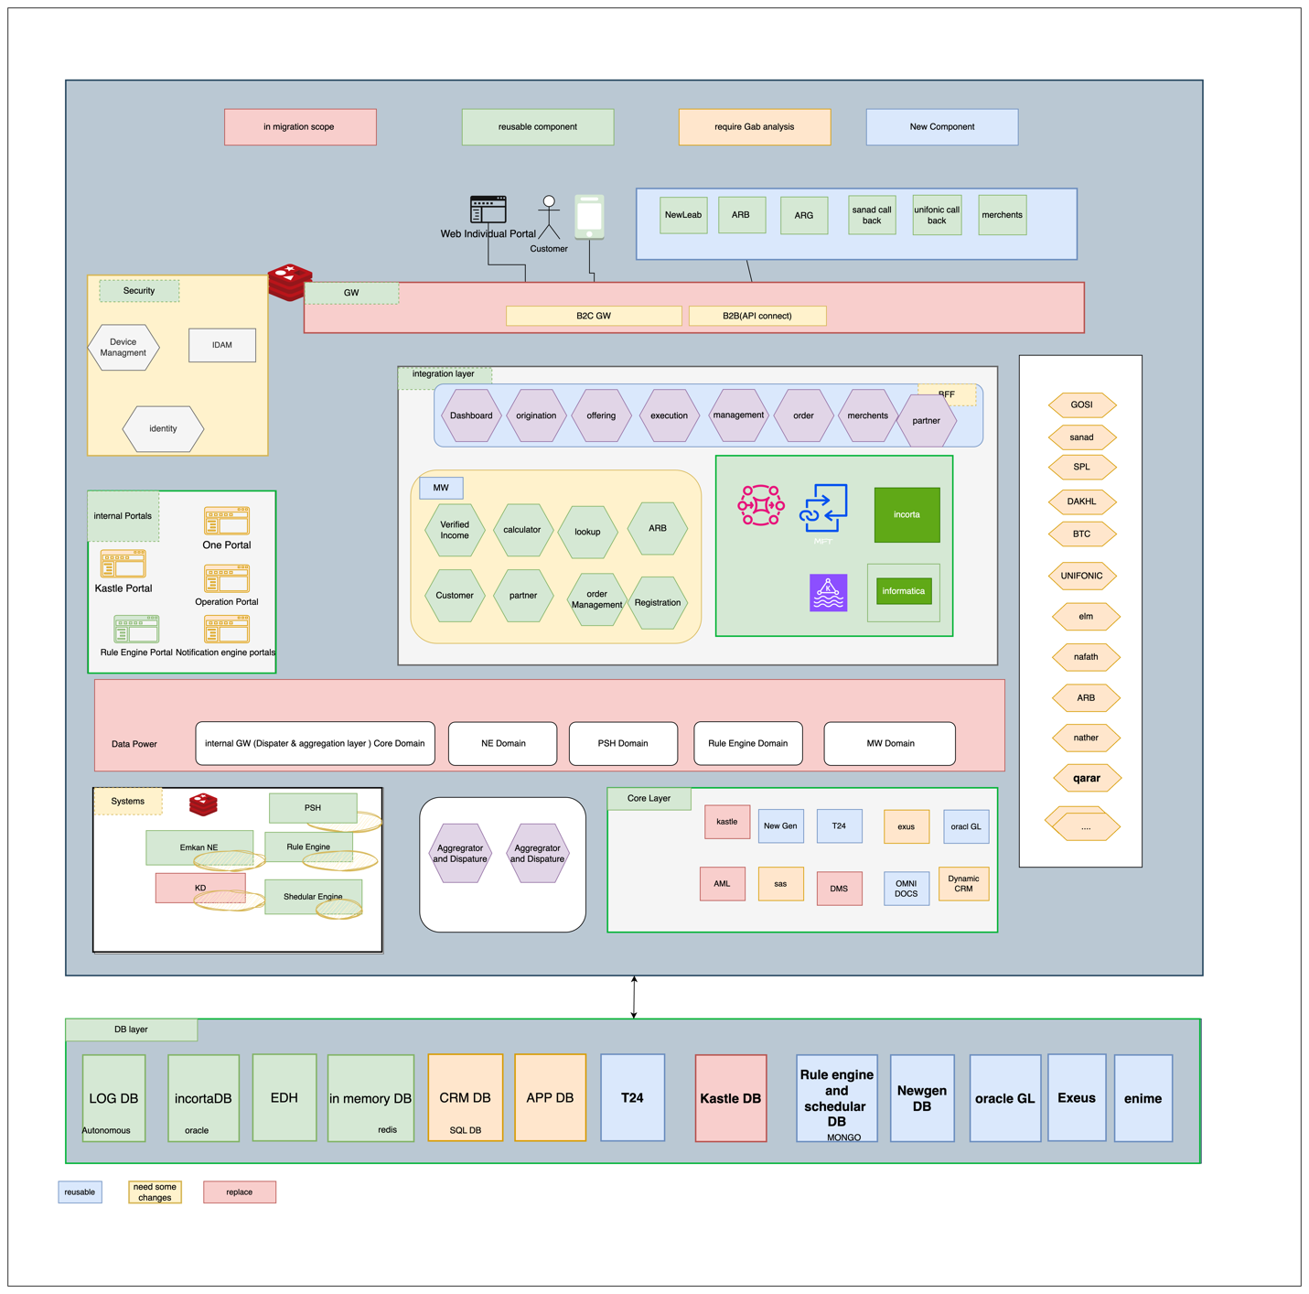

## Description

|  |  |  |
| --- | --- | --- |
| **Layer** | **Service/component** | **Role** |
| **Channels** | Mobile | Mobile App as customer interface |
| **Gateway** | External Gateway | External gateway [receiving traffic from external] |
| B2B Gateway | External gateway parteners |
| Internal Gateway | Internal gateway [handle communication between internal systems ] |
| APP Gateway[API-GW] | External gateway [receiving traffic from Mobile] |
| Dashboard | MS for doing transformation , aggregation,segregation ,... related to application dashboard communications like fetching all applications within stattistics from different core banking system,... |
| **Security** | IDAM(WSO2) | Identity Server for  identity and access management, |
| Identity Service | MS for identifying user [authentication/authorization] |
| Device Management | MS for managing registered device of customer |
| **Support Services** | Emkan NE | Notification Engine for sending notification like SMS,IVR, push Notification Message and feeback caller |
| Emkan Scheduler Engine | Scheduler Engine to Handling Job Tasks for Emkan |
| Emkan Rule Engine | Rule Engine to apply Ruel Sets |

# **Execution Flow View**

# Configuration

* + 1. **New Gen Configuration**:
* Configure below stage as unified stages for all products

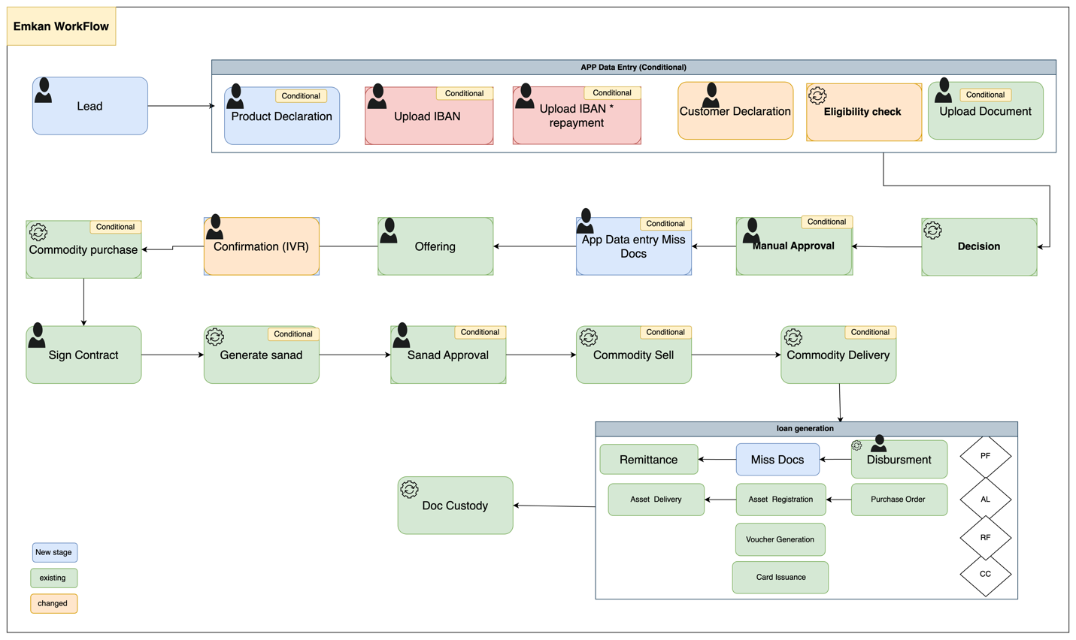

Description:

|  |  |
| --- | --- |
| **Task Name** | **Description** |
| Generate Request | Generating Unique identifier refer to Process-ID or Parent Application ID |
| Loan eligibility | Applying eligibility rules on customer |
| Screening | Checking customer sanction and screening |
| Customer declaration | Customer need to submit all expense, obligations ,income ,employer info , IBAN |
| Generate applications | Generate application[loans] per item |
| Upload Document | Customer submit document required |
| Decision | Final decision and final offer if accepted |
| Customer Offering Approval | Customer decides accept or reject final offer |
| Confirmation stage [IVR] | Triggering IVR call for loan confirmation |
| Commodity purchase maker | Purchasing commodity |
| Repayment Mode | Set repayment mode for customer |
| Sign contract | Customer accept /reject Sign contract of all applications |
| Generate Sanad | System generates PN for customer |
| Sanad Approval | Customer decides accept or reject Sanad |
| Commodity sell maker | Selling commodity |
| Disbursement | Disbursement Stage |
| Remittance | Remittance Stage |
| Document custody | Complete of process |

# Onboarding Flow

1. Diagram

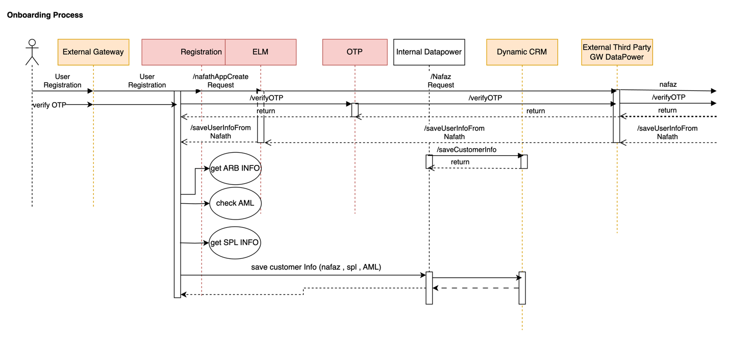

* 1. – branch flow

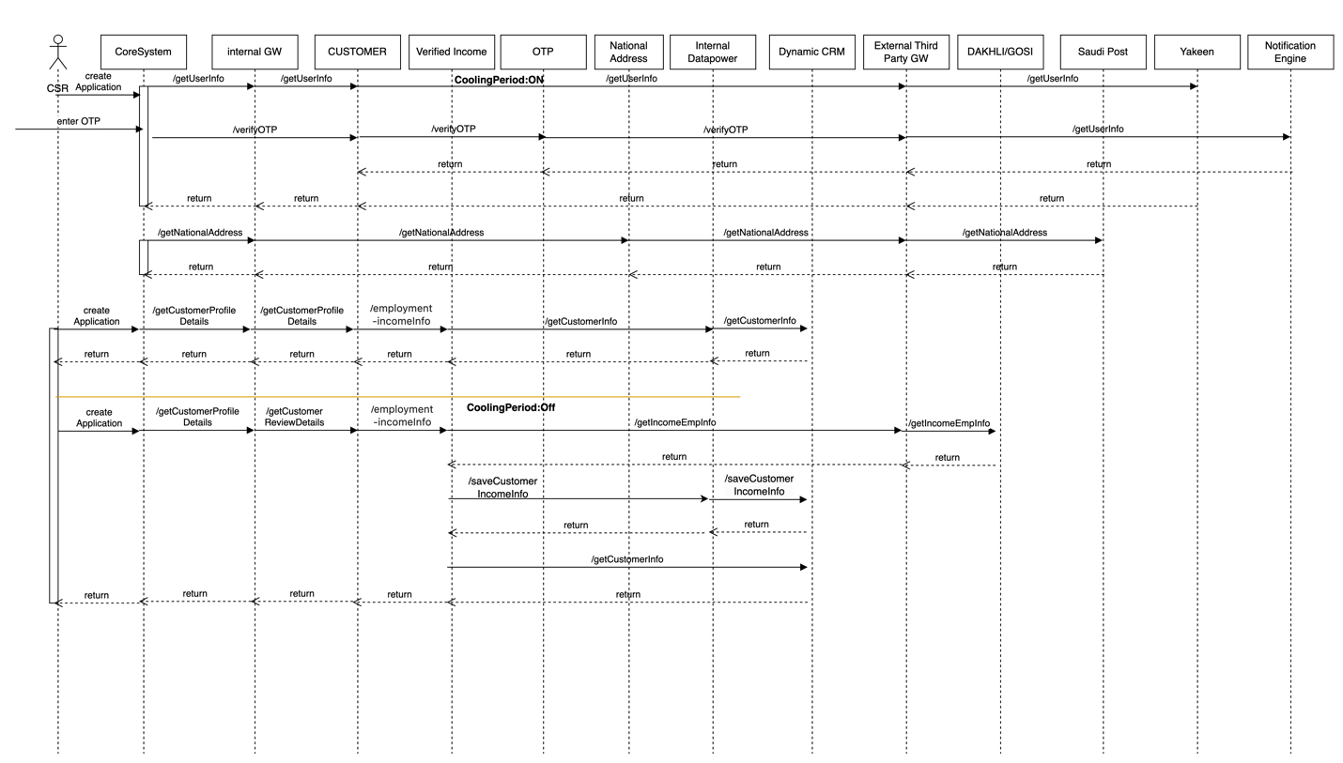

1. Description

# Dashboard Flow

1. Diagram
2. Description

|  |  |  |  |  |  |
| --- | --- | --- | --- | --- | --- |
| **System Provider** | **Action** | **Request** | **Response** | **Type** | **Description** |
|  |  |  |  |  |  |

# Loan Eligibility Flow (Lead Generation Flow )

* Diagram

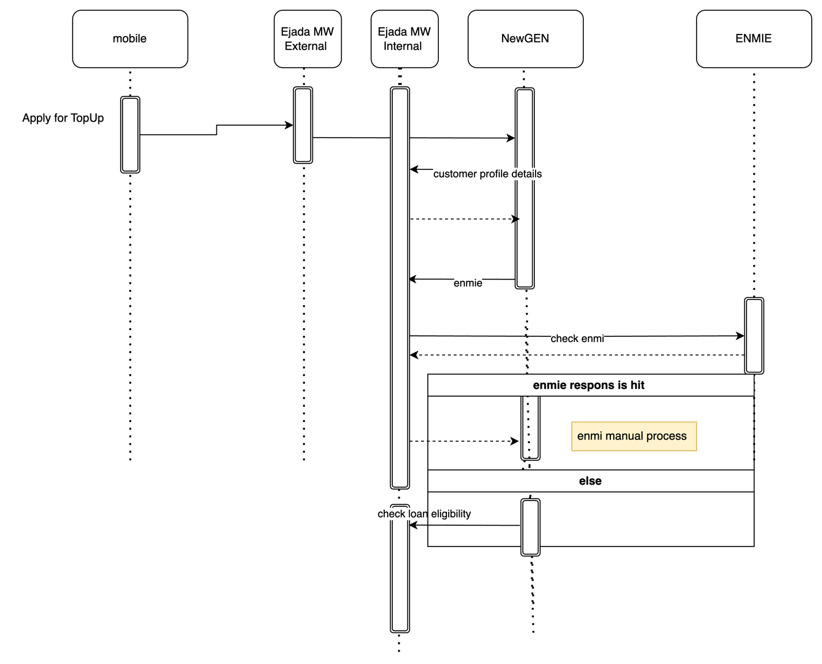

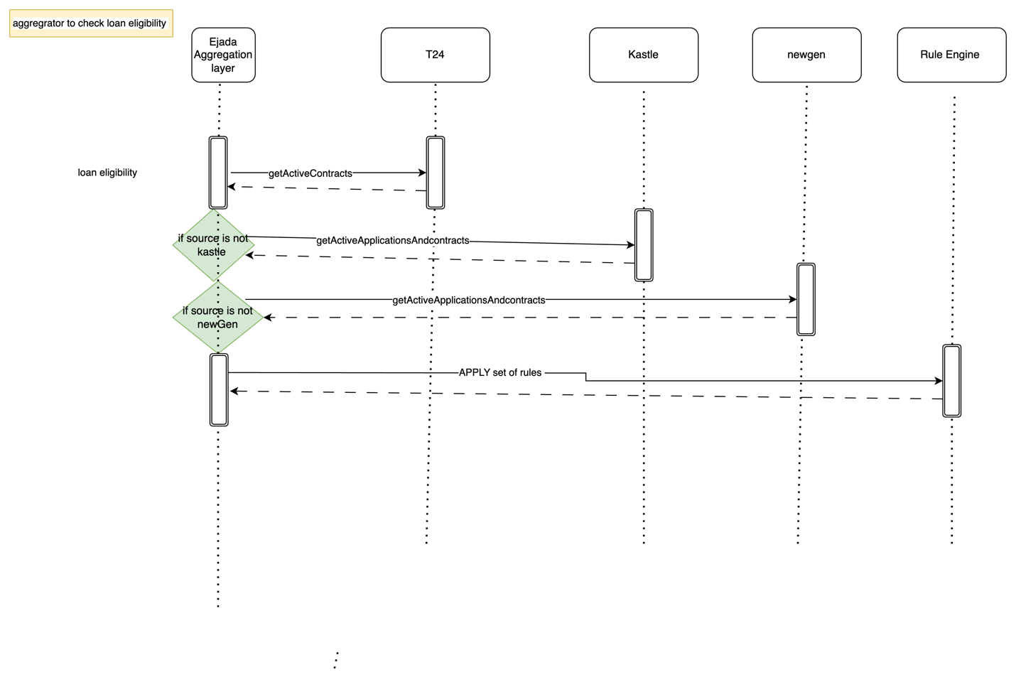

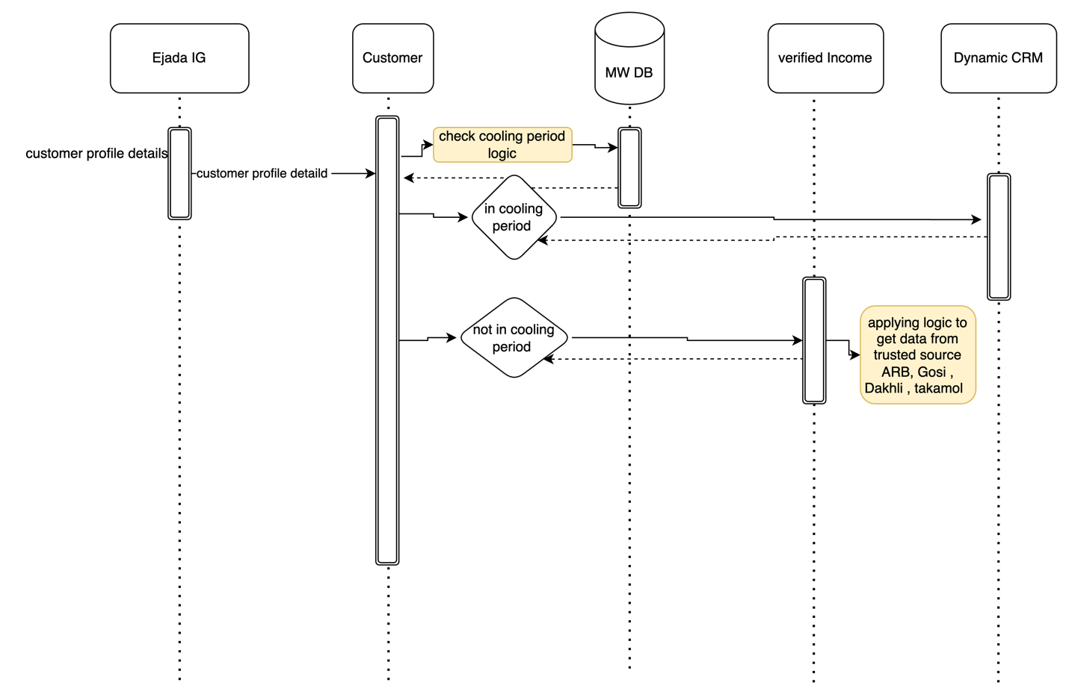

* Description

|  |  |  |  |  |  |
| --- | --- | --- | --- | --- | --- |
| **System Provider** | **Action** | **Request** | **Response** | **Type** | **Description** |
|  |  |  |  |  |  |

# Quality Flow

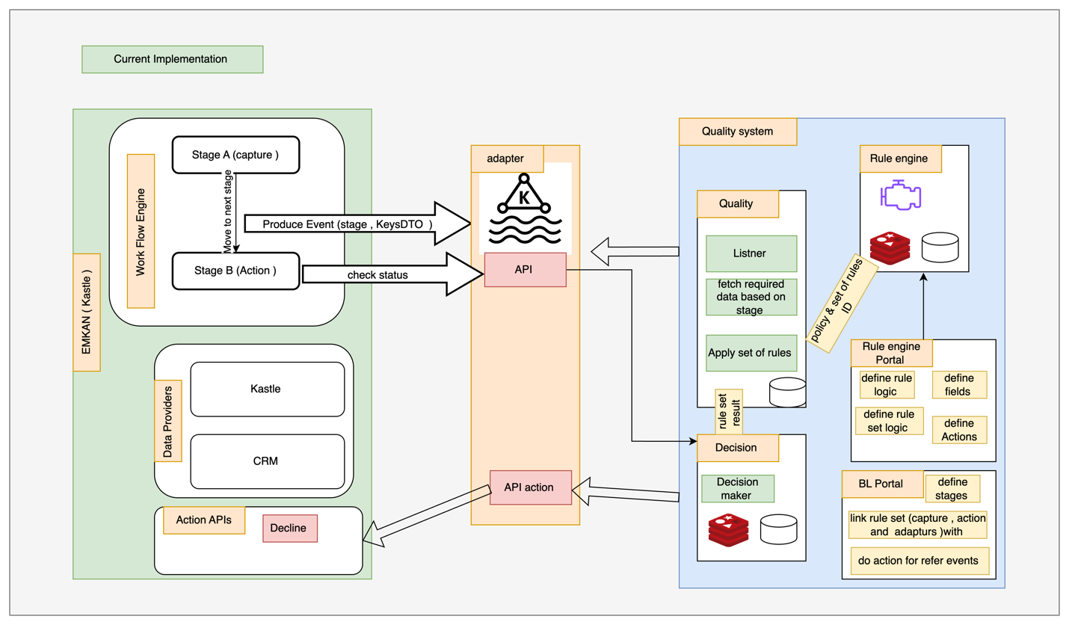

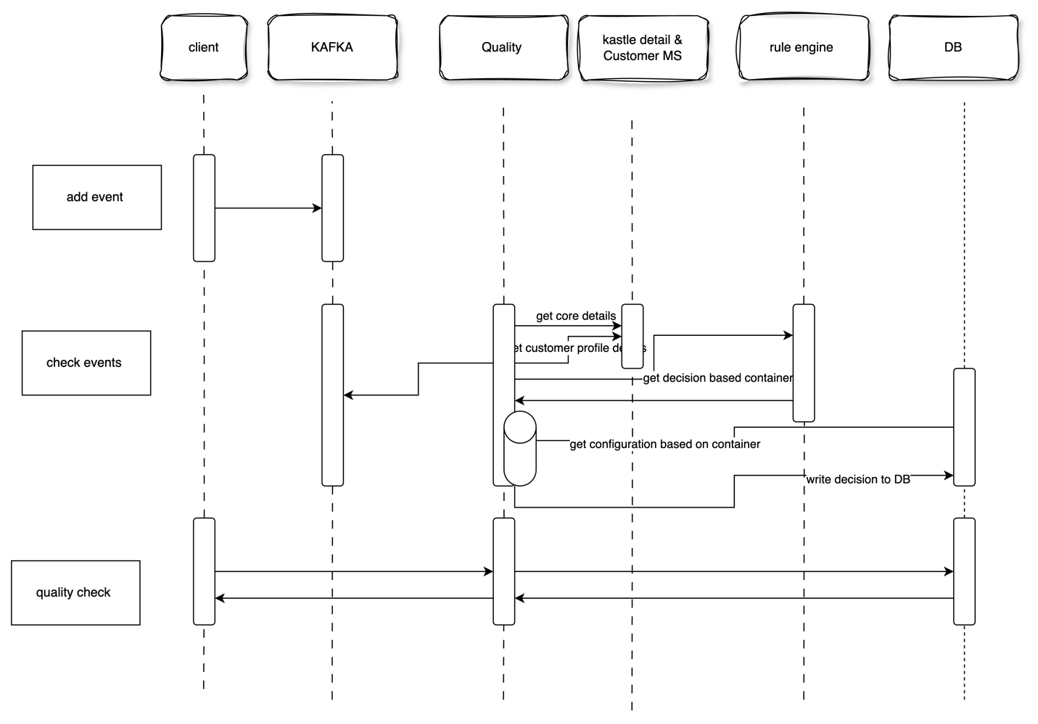

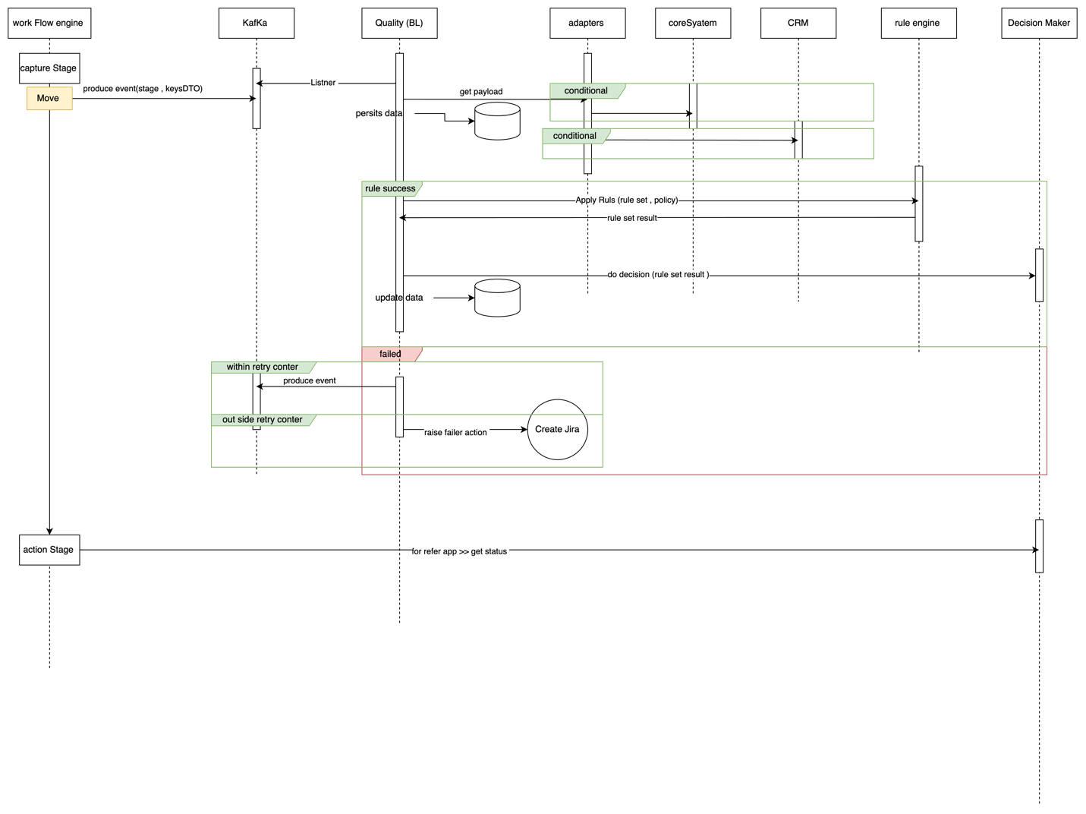

# IBAN Verification

# Customer declaration

* Diagram

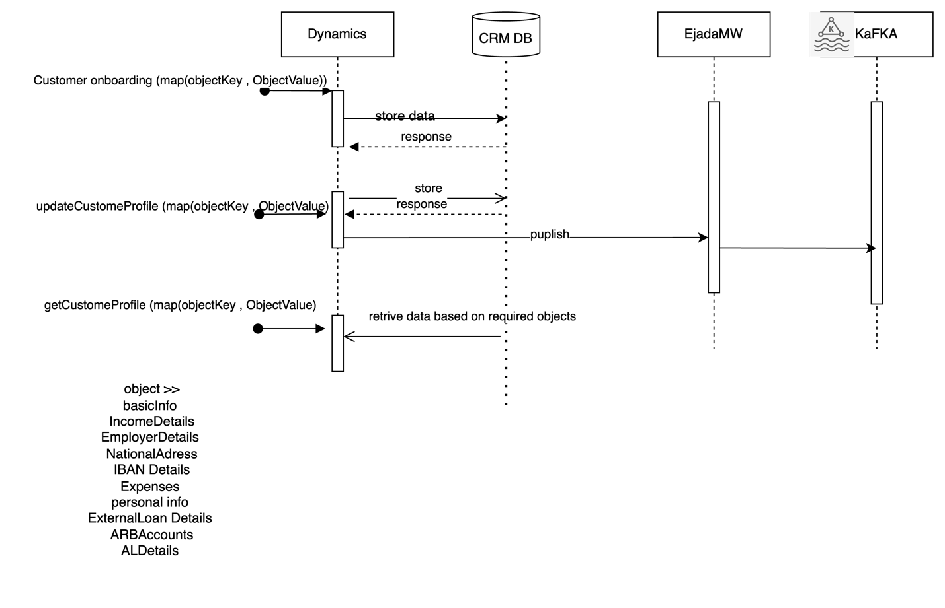

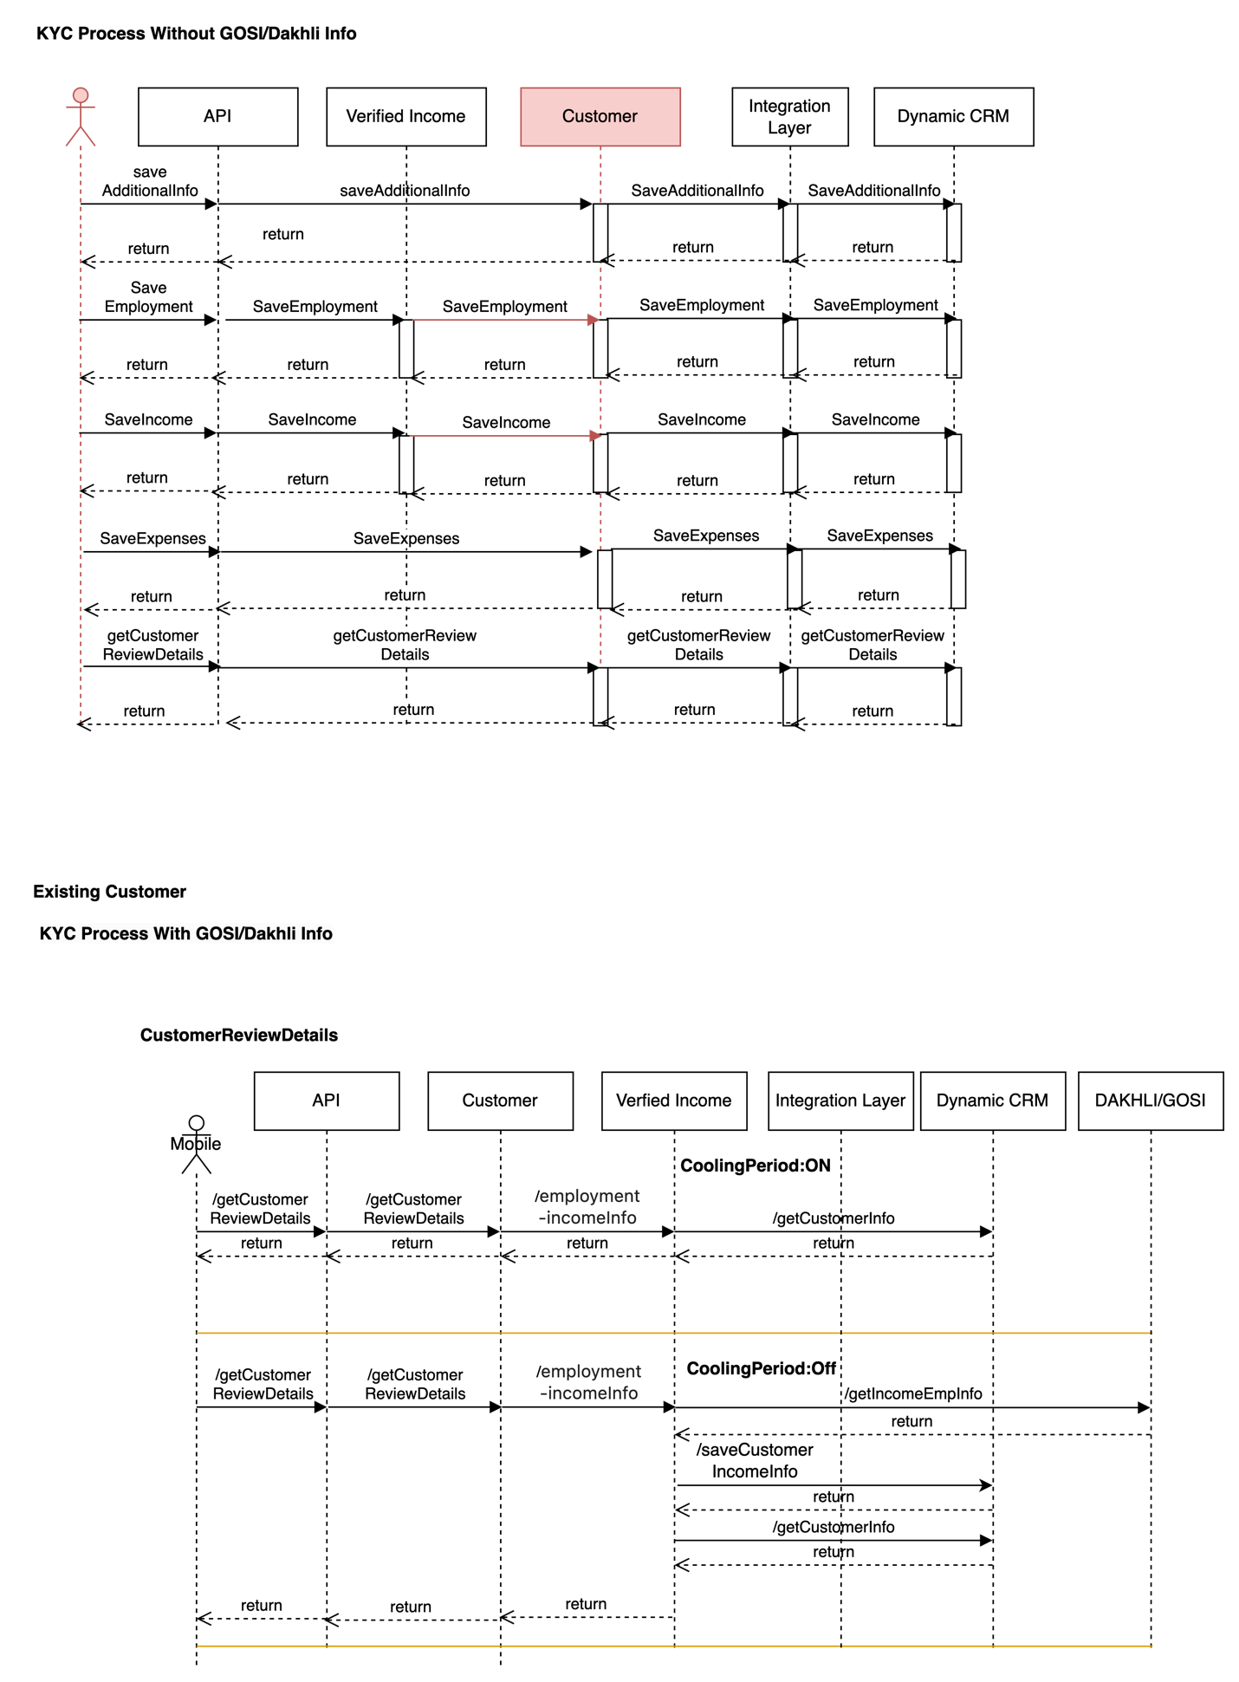

* Description

|  |  |  |  |  |  |
| --- | --- | --- | --- | --- | --- |
| **System Provider** | **Action** | **Request** | **Response** | **Type** | **Description** |
|  |  |  |  |  |  |

# product Eligibility check

* Diagram
* Description

|  |  |  |  |  |  |
| --- | --- | --- | --- | --- | --- |
| **System Provider** | **Action** | **Request** | **Response** | **Type** | **Description** |
|  |  |  |  |  |  |

1. Description

# Upload Document Flow

Design Overview

* Diagram
* Description

|  |  |  |  |  |  |
| --- | --- | --- | --- | --- | --- |
| **System Provider** | **Action** | **Request** | **Response** | **Type** | **Description** |
|  |  |  |  |  |  |

# Loan Offering Flow

Design Overview

* Diagram
* Description

|  |  |  |  |  |  |
| --- | --- | --- | --- | --- | --- |
| **System Provider** | **Action** | **Request** | **Response** | **Type** | **Description** |
|  |  |  |  |  |  |

# Loan Execution Flow

Design Overview

* Diagram

IVR

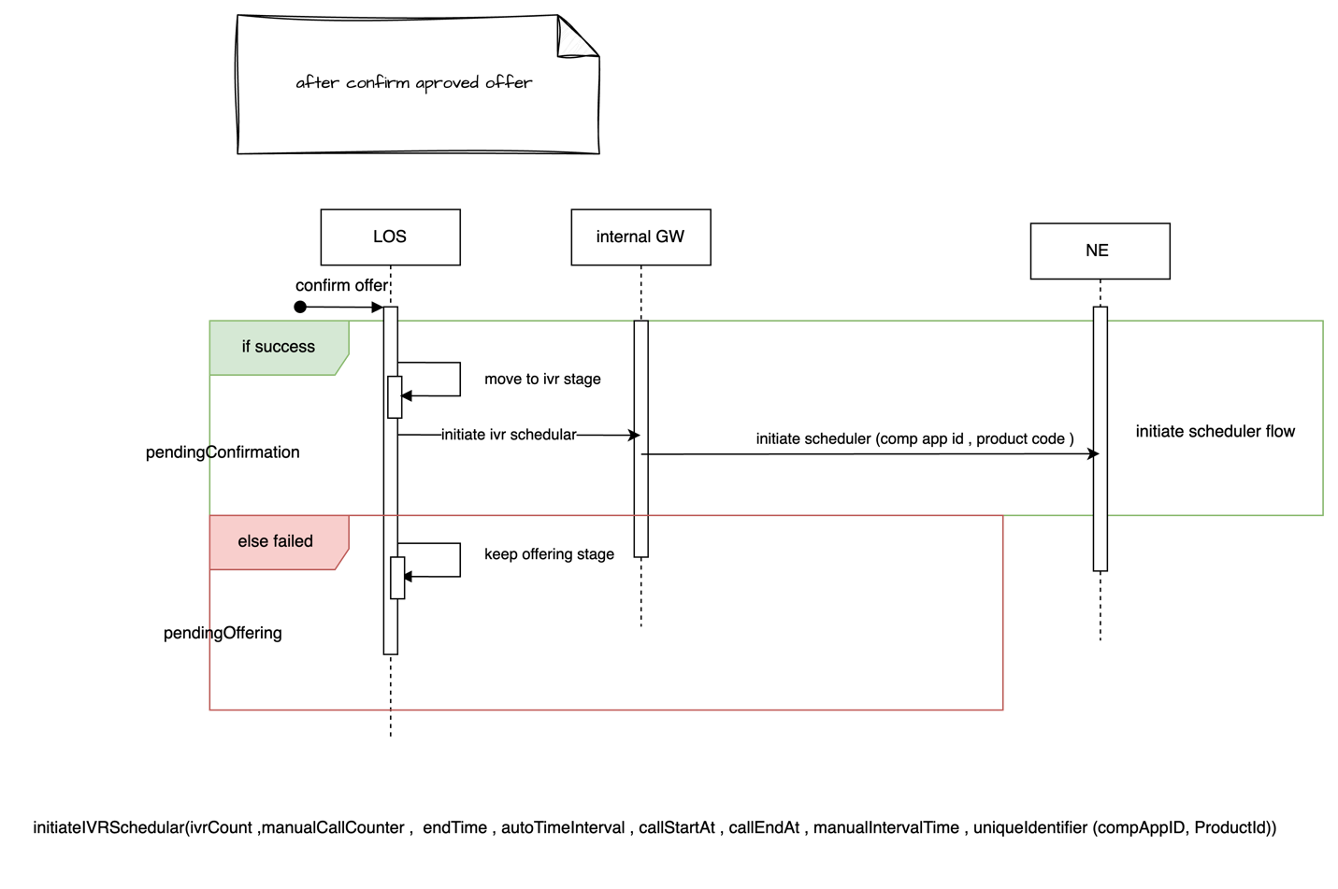

Mobile Flow

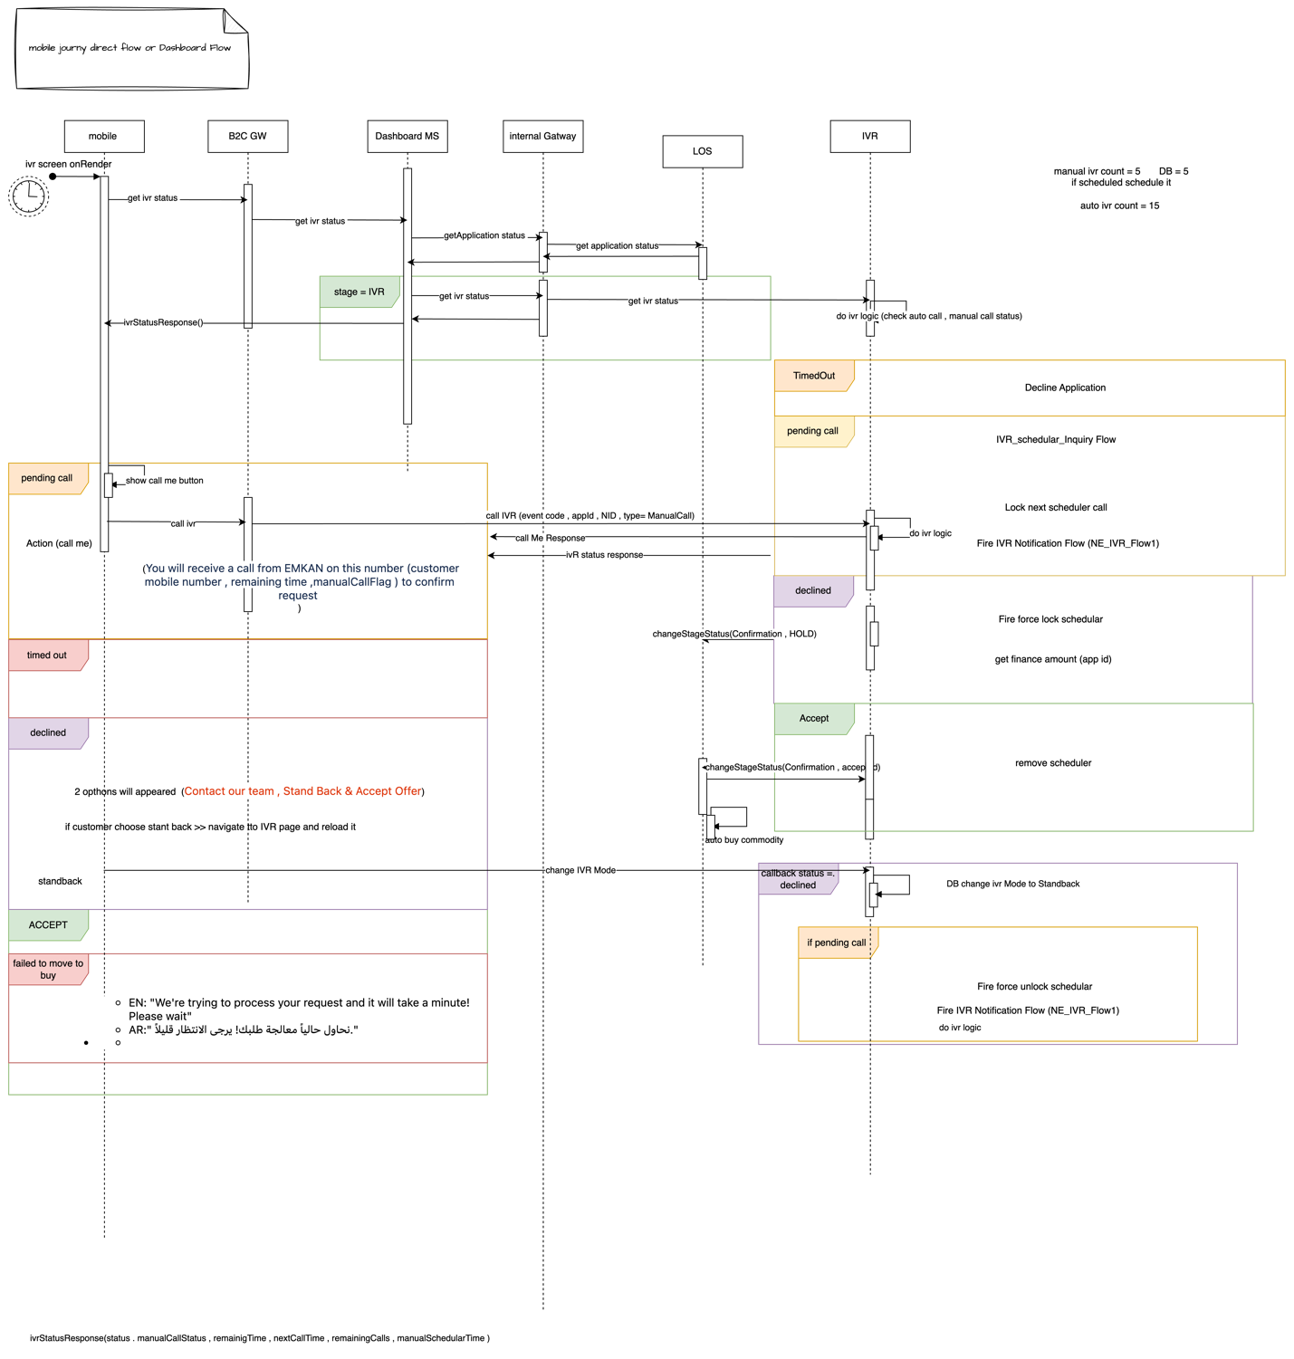

Interaction between NE and Core System

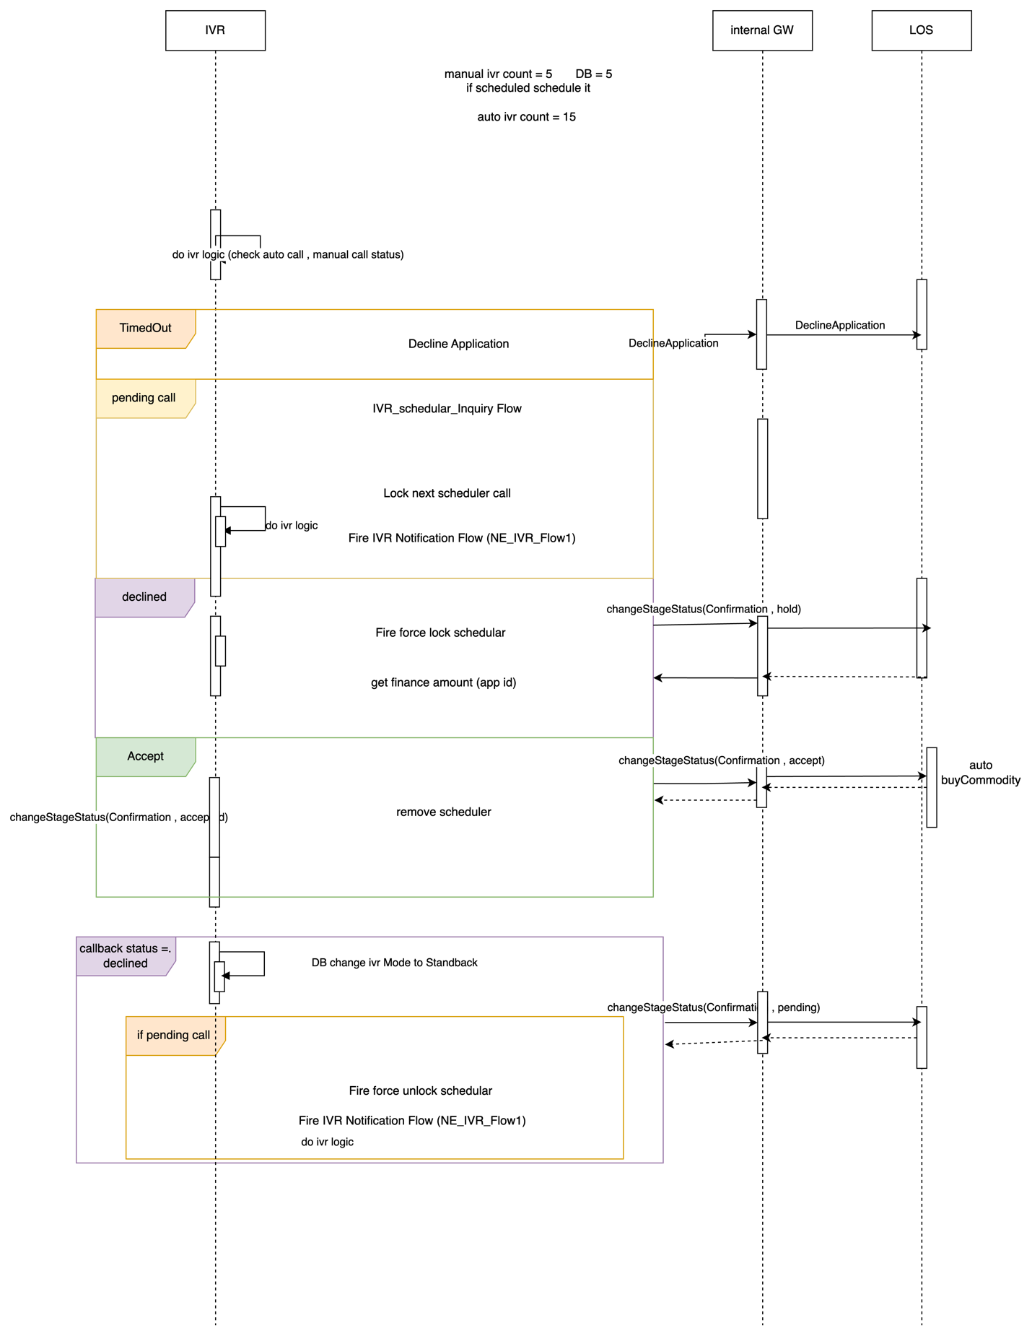

IVR CallBack

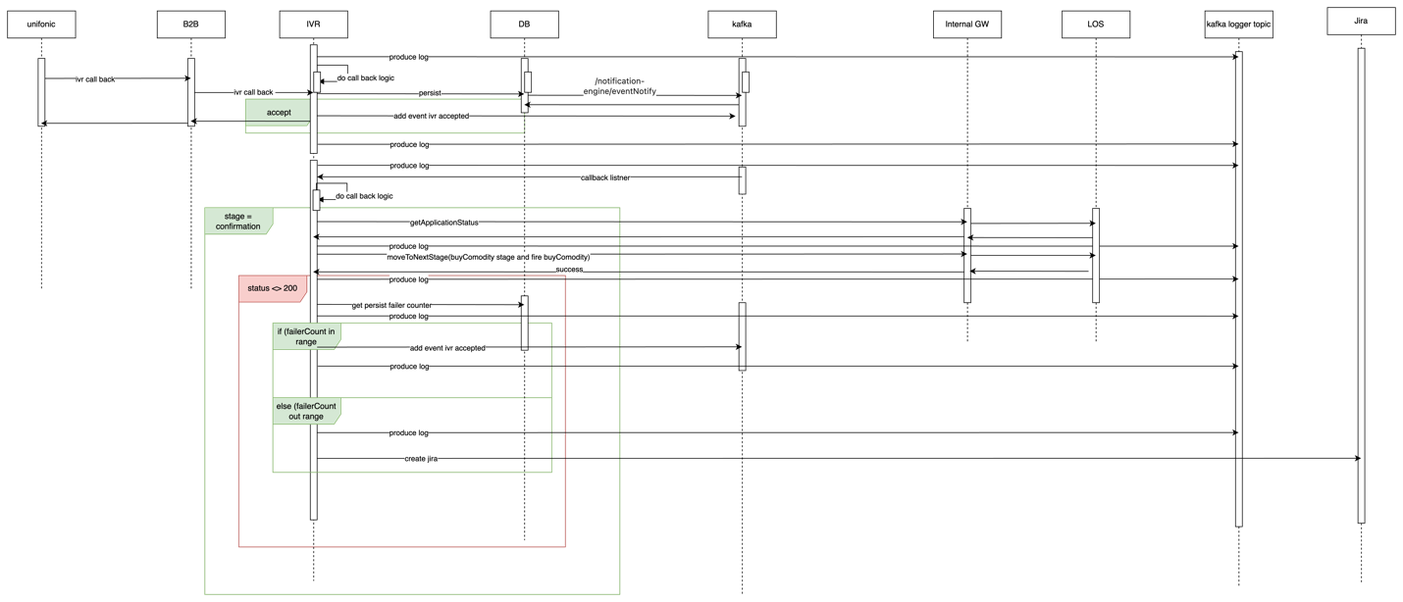

Get Sale Authorization

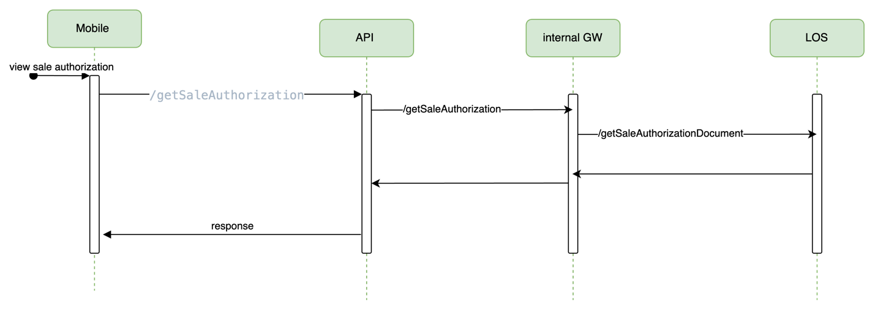

Sign Contract Screen

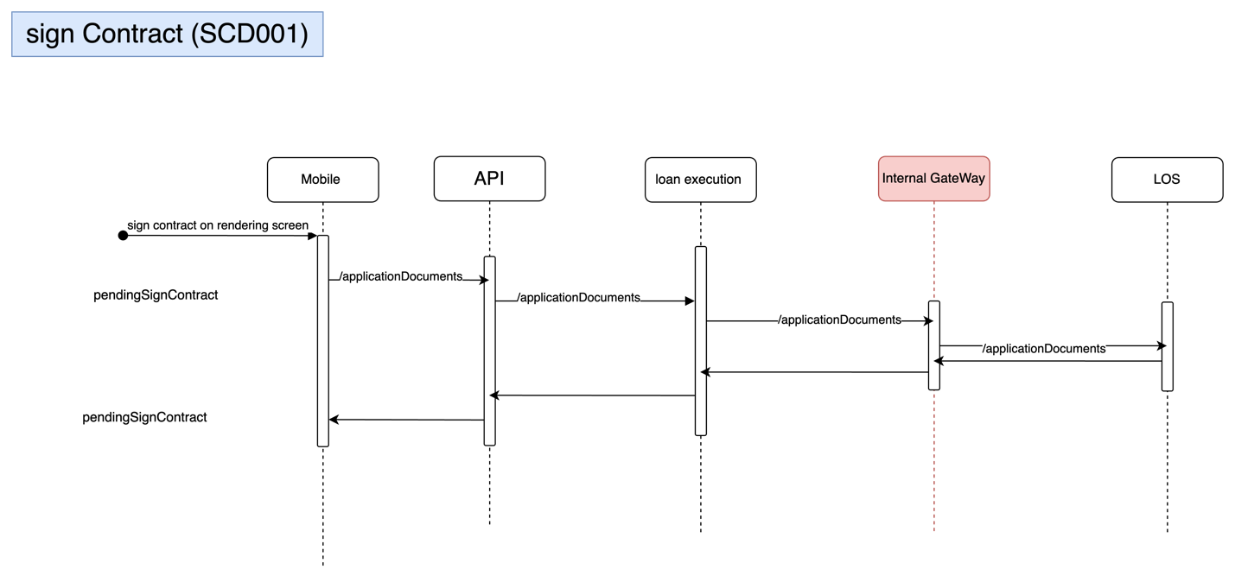

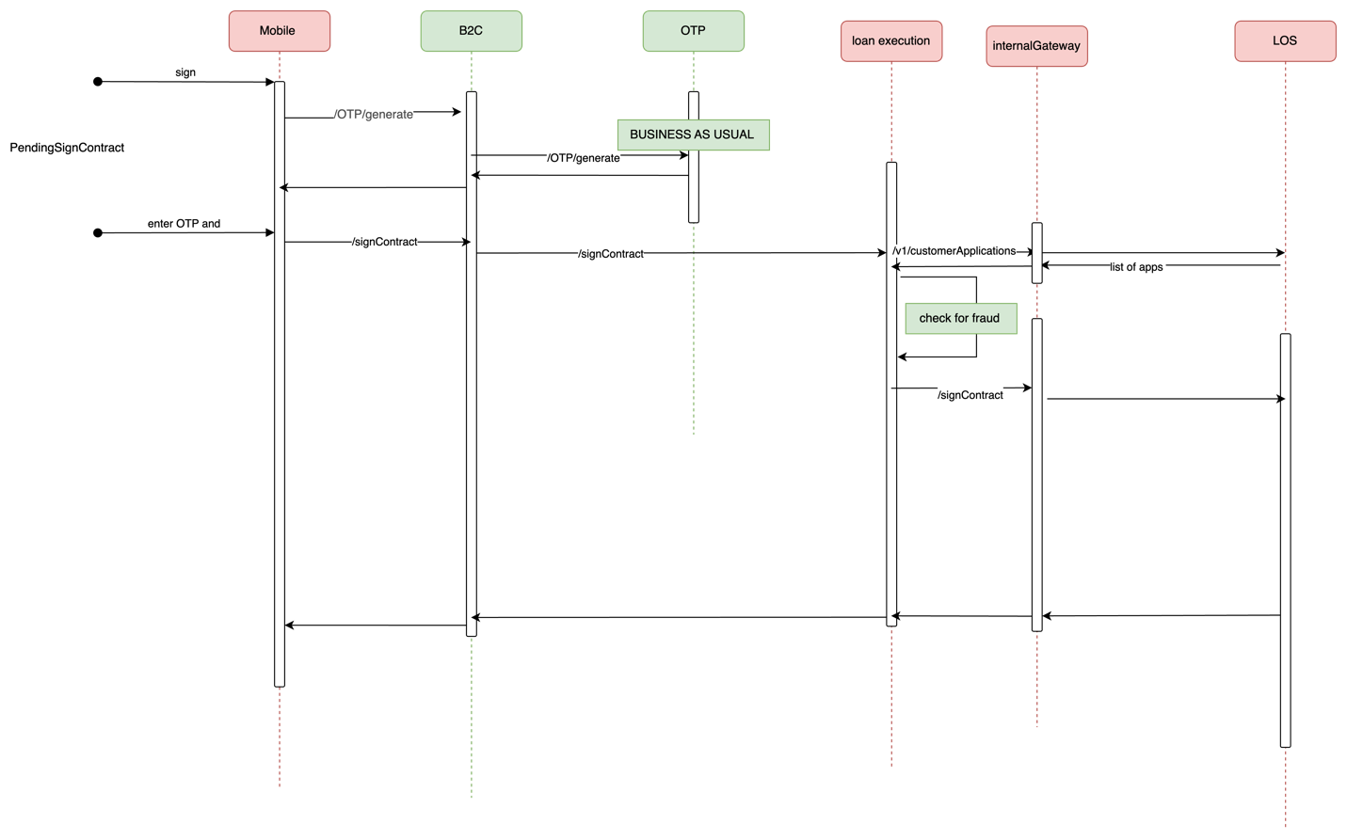

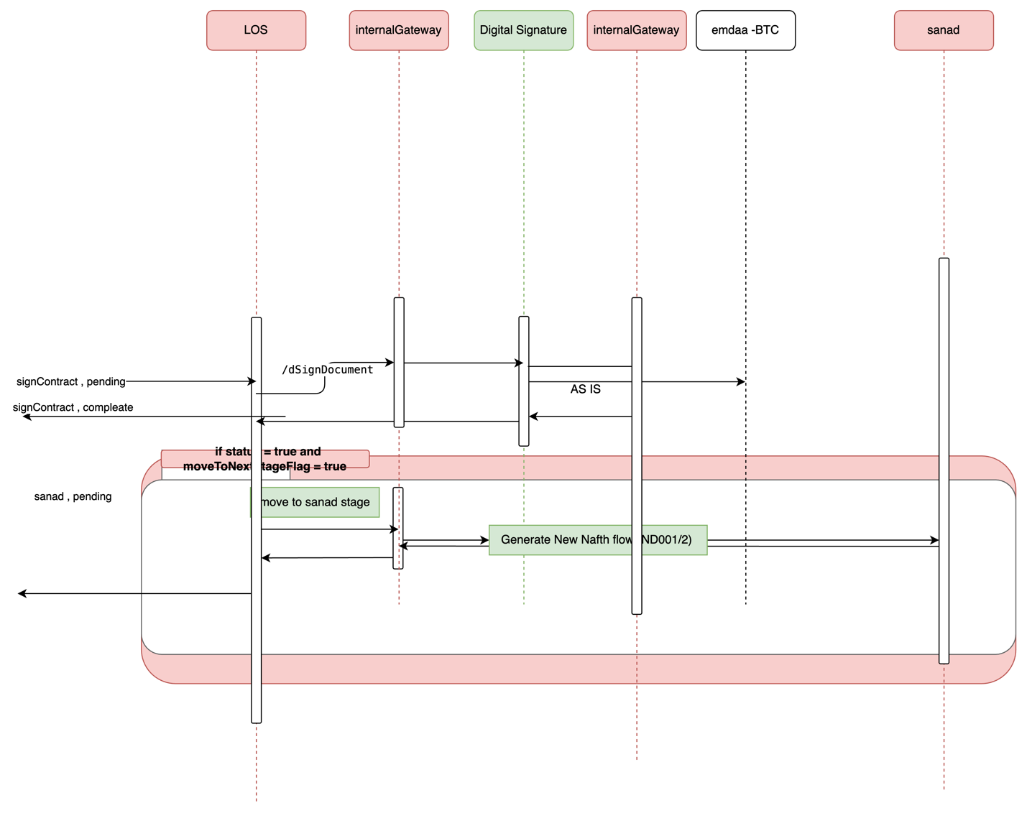

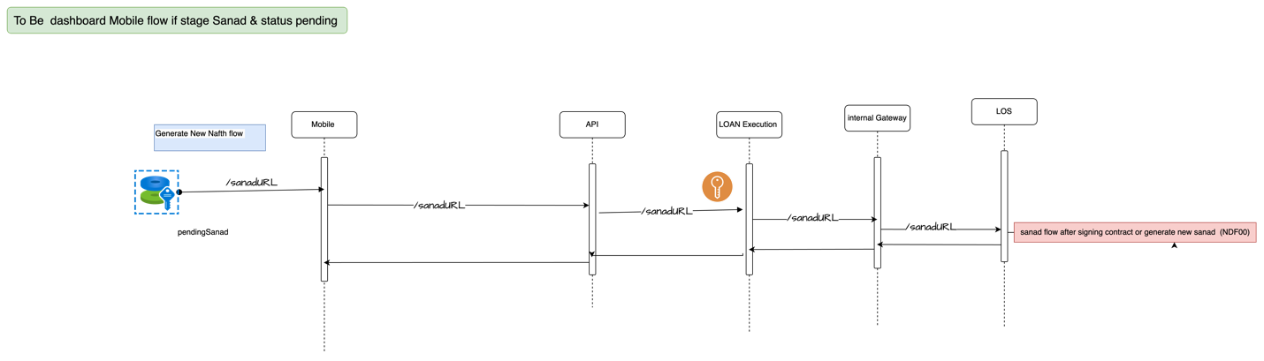

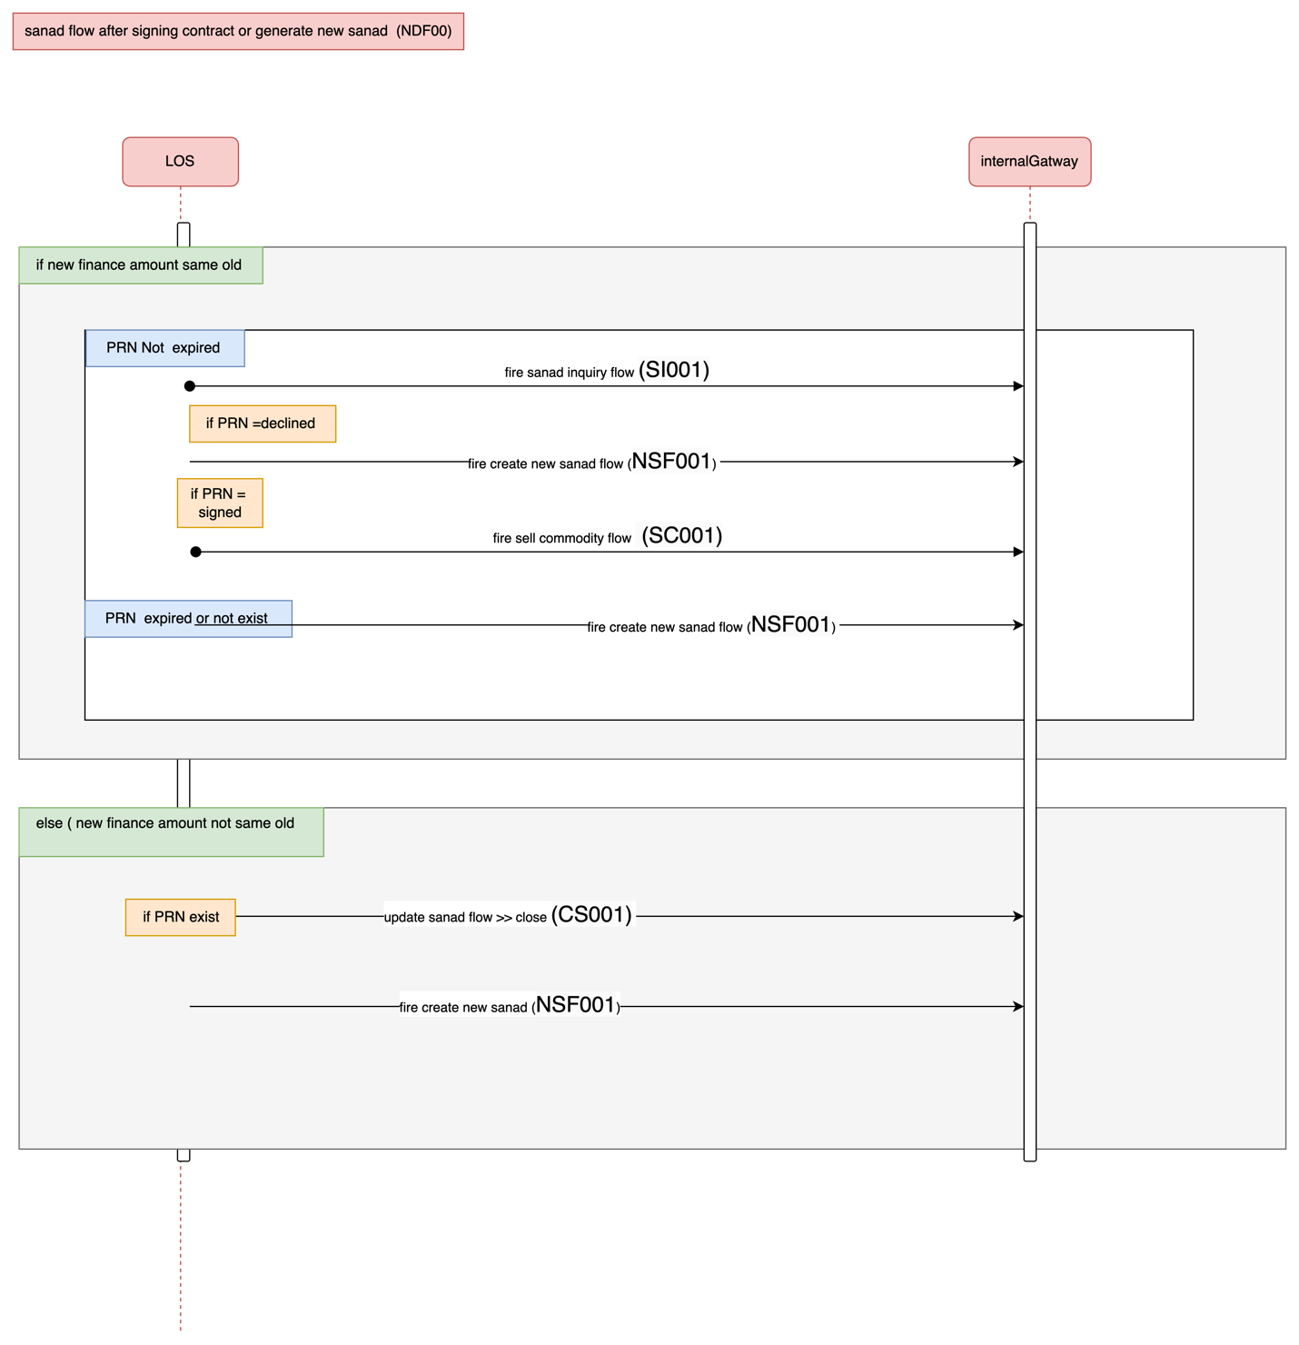

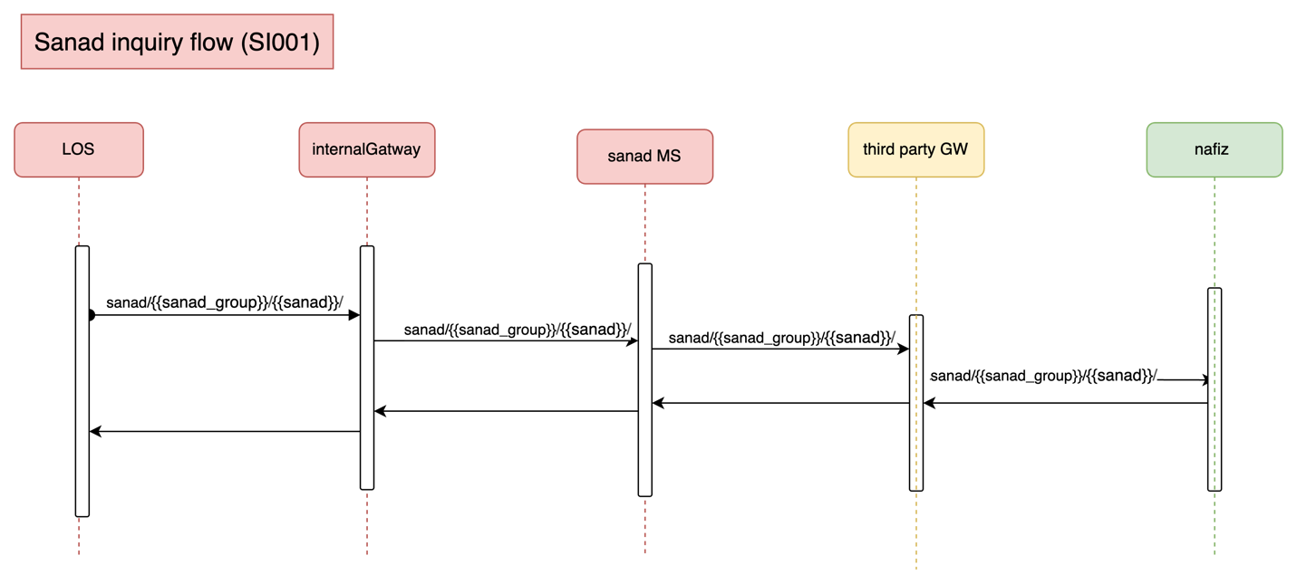

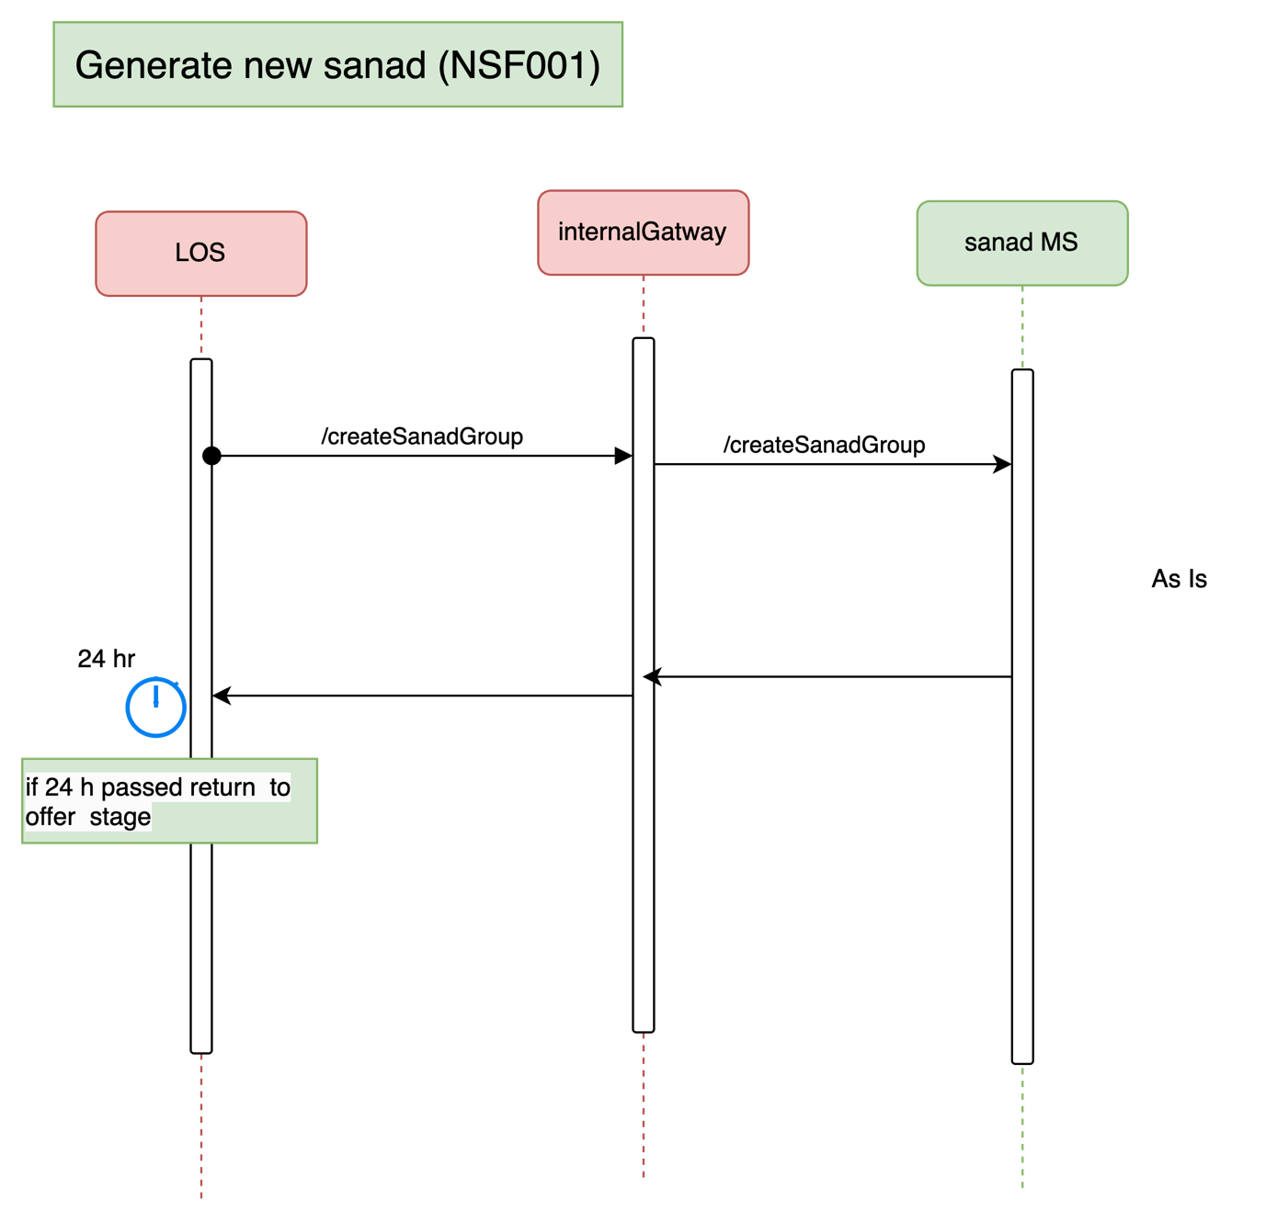

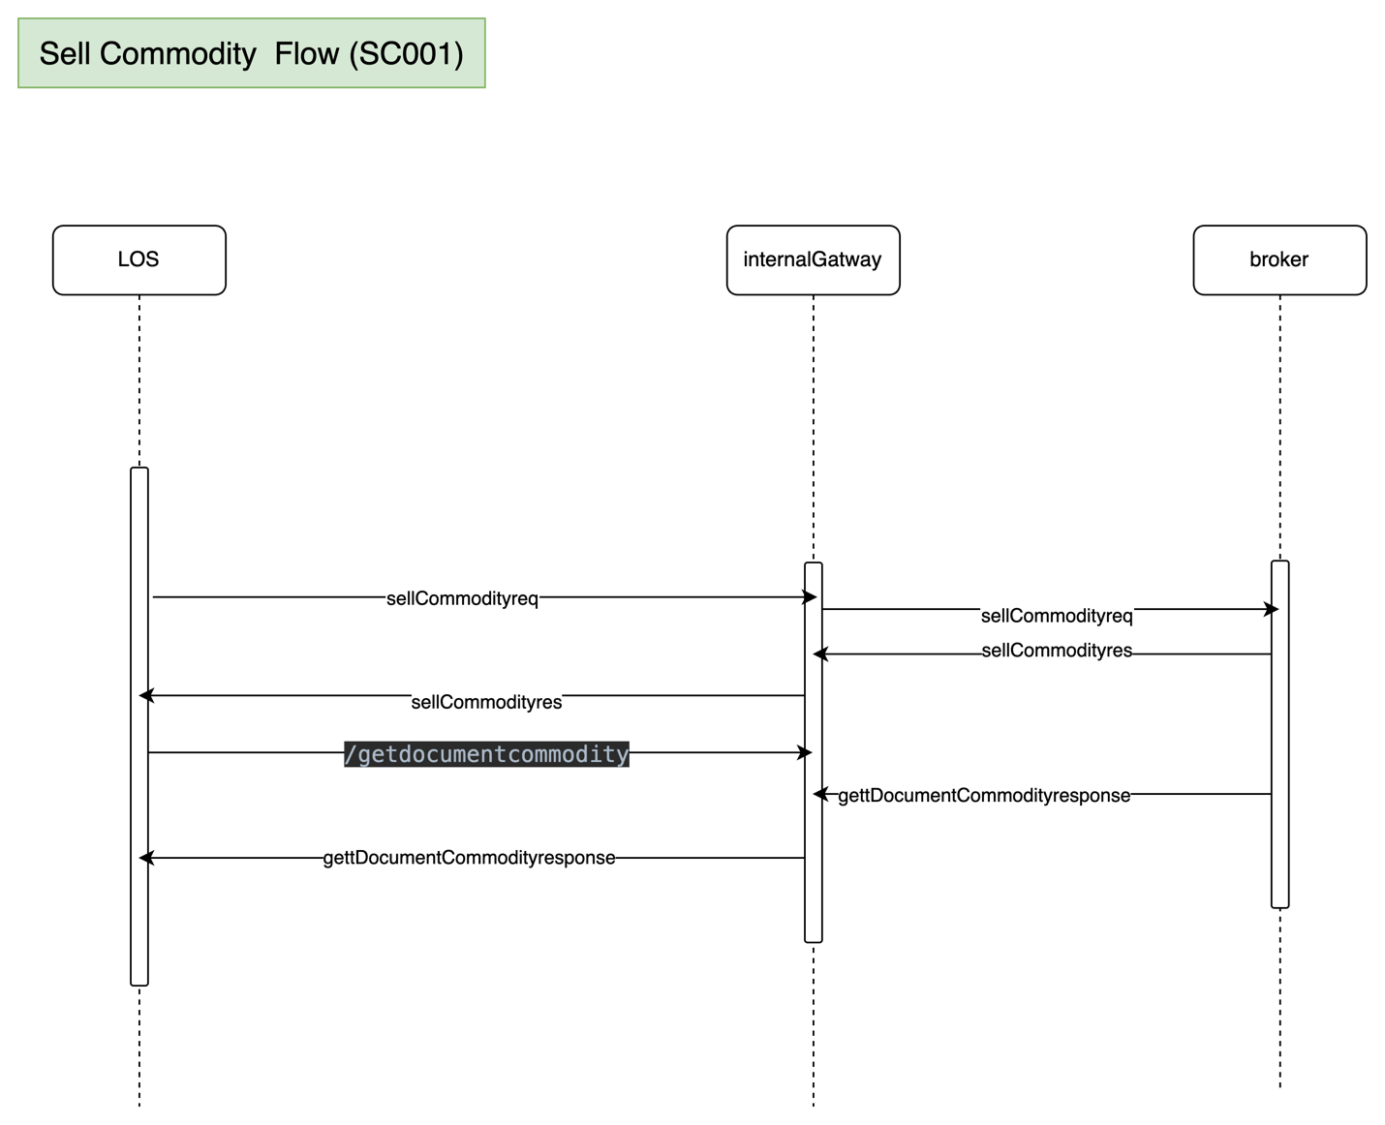

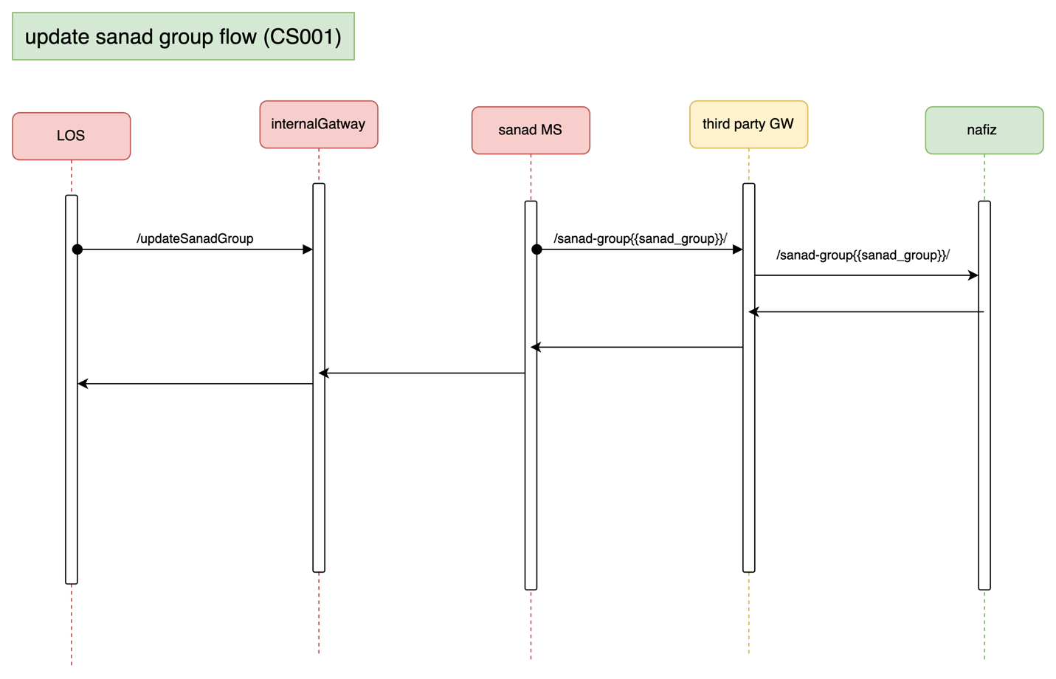

# 

# 

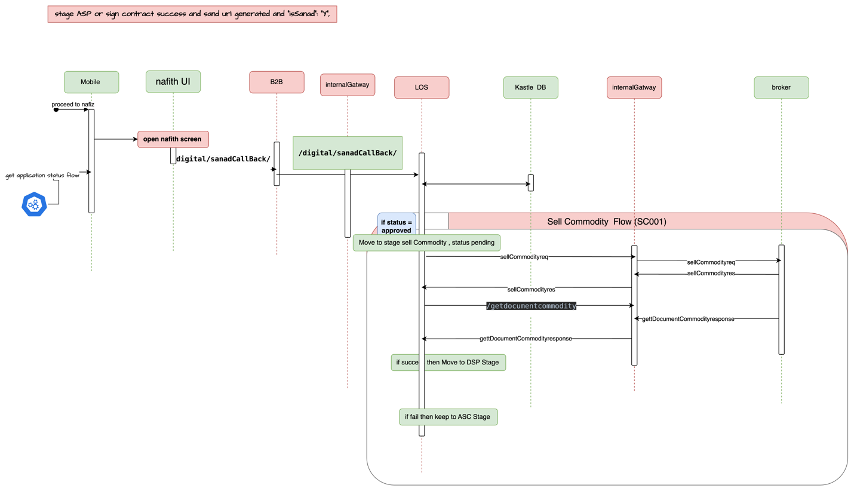

Receiving call back require change from Sanad

Disbursement Flow

# Entity Relation:

TBD

|  |  |  |
| --- | --- | --- |
| **Domain** | **Data Object** | **Description** |
|  |  |  |
|  |  |
|  |  |
|  |  |
|  |  |
|  |  |
|  |  |
|  |  |
|  |  |
|  |  |
|  |  |
|  |  |
|  |  |
|  |  |
|  |  |

# **Deployment and Security View**

TBD

# 

# Appendix A - Architectural Decisions

|  |  |  |  |
| --- | --- | --- | --- |
| Subject Area |  |  |  |
| Architectural Decision |  |  |  |
| Issue or Problem Statement |  | | |
| Assumptions |  | | |
| Motivation |  | | |
| Alternatives |  | | |
| Decision |  | | |
| Justification |  | | |
| Implications |  | | |
| Derived requirements |  | | |
| Related Decisions |  | | |

## Using Shedlock to handle schedular

|  |  |  |  |
| --- | --- | --- | --- |
| Subject Area | Scheduler Engine |  |  |
| Architectural Decision | Shedlock instead of Quartiz |  |  |
| Issue or Problem Statement |  | | |
| Assumptions |  | | |
| Motivation |  | | |
| Alternatives | Using   1. Quartiz 2. Spring @schudeler | | |
| Decision |  | | |
| Justification |  | | |
| Implications |  | | |
| Derived requirements |  | | |
| Related Decisions |  | | |

# Appendix D – Failing Retry Policy

|  |  |  |  |  |
| --- | --- | --- | --- | --- |
| **System** | **Error Code** | **Retry Mechanism** | **Max Number of Retry** | **Alternative after Pass Max No of Retry** |
| Emkan Services | Not http “200” | Exponential back off  Starting with interval 5 mins | 20 | Sending Email |
| “Newgen”,MW | Not http “200” | Retry every 10 min | 20 | Sending Email |

# Appendix E – Cooling Period

|  |  |  |
| --- | --- | --- |
| **Stage/Type** | **Cooling Period** | **System Owner** |
| IVR |  |  |
| signing contract | 24 h | kastle |
| generate sanad |  |  |
| sanad approval | 24 h | kastle |
| commodity sales maker | 24 h | kastle |
| commodity delivery |  |  |
| document custody |  |  |

# Appendix R – Risks

|  |  |  |
| --- | --- | --- |
| **Stage/Type** | **Risk** |  |
|  |  |  |
|  |  |  |
|  |  |  |

# Appendix I – General Impacts

|  |  |  |
| --- | --- | --- |
| **owner** | **stage** | **impact** |
| MW |  |  |
|  |  |  |
|  |  |  |